Predictive Analytics Tool – SAS

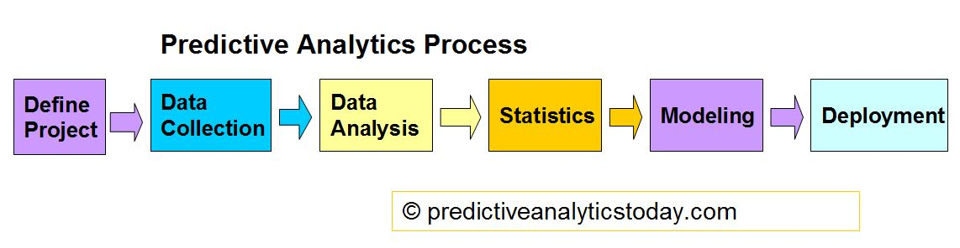

What is predictive analytics? Predictive analytics use many techniques from data mining, predictive modeling and analytical intelligence to analyze, in order to make predictions about the upcoming unknown future. The outcomes of predictive analytics allows company or organization to become more positively, forward-looking to the achievement and goal build up upon the data; which is not just a assumption or intuition.

SAS

Predictive analytics tools are the techniques to achieve the prediction of predictive analytics. There are open source freeware, proprietary software, software API and tools for different uses. Today I am going to talk about SAS, the most well known predictive analytics software of all time.

SAS stands for Statistical Analysis System, a business analytics software and services original developed by North Carolina State University back in 1966. SAS is design for power-users, SAS provides two ways to interpret data, one is using point-and-click like UI which is user-friendly, and a more advanced option by using the SAS language.

One of the advantages of SAS is the visualization that SAS own the most powerful graphing tools among all the tools. An essential part for predicting data is the visualization which can be use to explore data visually and find out new patterns in order to make assumption for the future data. For the data management, SAS is very powerful at managing data, it is because SAS includes PROC SQL which allows queries in the data files. The PROC SQL is the implementation of Structured Query Language, which is used for preserving data in tables and databases. PROC SQL also has substantial data manipulation and summarization capabilities and can be use to replace the old SAS code to reducing programming time and increase efficiency.

SAS predictive modeling techniques

The three well-known methods of predictive analytics are decision trees, regression and neural networks.

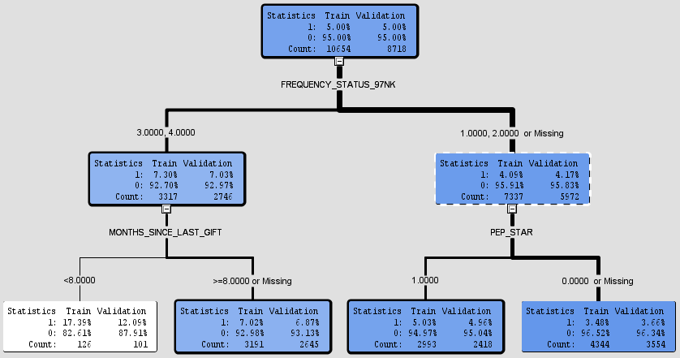

Decision Trees:

A way to classify input data based on categories and types. It can easily tell the reader how the decision’s direction. Decision tree can handle missing value very well.

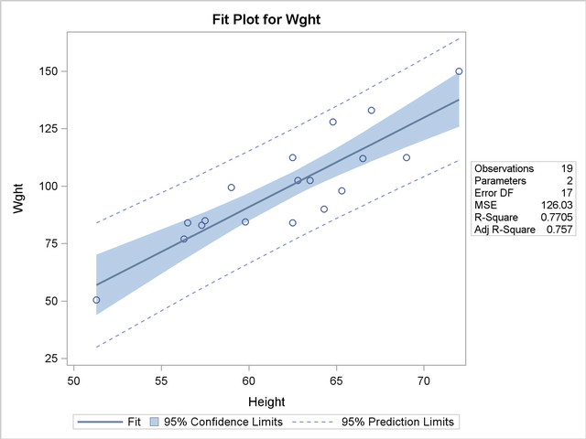

Regression:

The regression method owns a wide variety of models that can be applied while performing predictive analytics. Such as, linear regression, logistic regression and multinomial logistic regression. The linear regression model is based on analyzing correlation of a dependent variable and a set of independent variables. After the model has been determined, the goal of the model is to understand whether the predictor variables belong in the model. And it can be use to estimate of each variable's reliability using t-test.

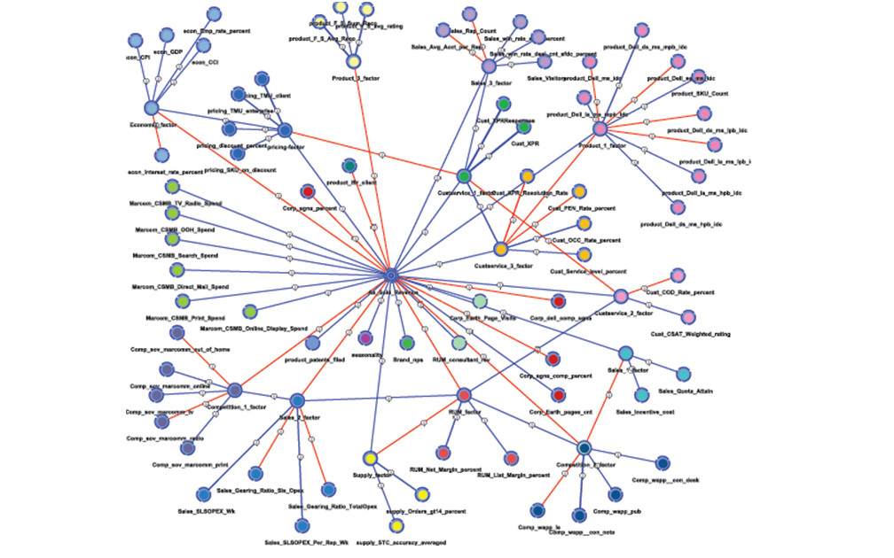

Neural Networks: Technique of modeling an extremely complicated network. Neural networks are famous for their flexibility, because they can handle nonlinear network data. It work well when the input/output of the data could not formulate with formula and while there is a lot of training data. The original idea of Neural Networks is based on the neural connection of human brain.

Beside the techniques mention above, there is still a huge variety of methods of predicting the data using the technique we have learn in class such as, SVM, KNN, Naïve Bayes and so on.

Because SAS requires SAS language to program and it is geared towards advance users. After all, advance users enjoy its powerful data management while working with numerous data files at once.